# Predicting Locations for a Food Truck Business

## Amita Dsa

## May 22, 2019

1. **Introduction**

**1.1 Background**

An individual is looking to start a Food Truck Business in Downtown Toronto Canada. They need recommendations on which neighborhood locations are the best for the same.

The neighborhood selected should have a demand for food trucks and also pre-defined spots where a good footfall of Customers can be expected.

**1.2 Problem**

We first need to figure out who are our Target Customers are from the below sets and then build a plan to cater the same -

1) Shopping Center Visitors

2) Construction Workers

3) Business District Employees or

4) College Kids

From the above set, Bustling Business District Employees require catering during Lunch Time. So, if we target Business District Employees by getting Street parking around the Office buildings it will have a good footfall. Similarly, Snacks & Ice Creams can be catered to Shopping Center Visitors/ College crowds and so on.

Fixing the Menu for the Food Truck is the next step -

We will need to plan the food menu around on Cuisine specific items or Fast Foods like Sandwiches/Pizza and so on. Based on the Target crowd, our food menu will require to be altered.

We are now ready to define our Problem Statement -

Which neighborhood’s or locations are the best in Downtown Toronto to launch a Food Truck business?

* 1. **Interest**

This study will help all future business owners with competitive advantage and business values.

**2. Data acquisition and cleaning**

**2.1 Data Sources**

* Foursquare API data based on search criteria for Business and Education
* Wikipedia site for Postal codes of Canada

**2.2 Data Cleaning**

For Data Cleaning, we have first ensured that all empty spaces in the columns have been removed and the data types match correctly as expected. During the web scraping activity there were some null records created which also have been cleaned so that it matches correctly with the source.

The data-frames have been filtered as per the modeling logic used in the study. During merging of data between Wikipedia and Foursquare, we have renamed column Postcode so that an inner join can be create on the same.

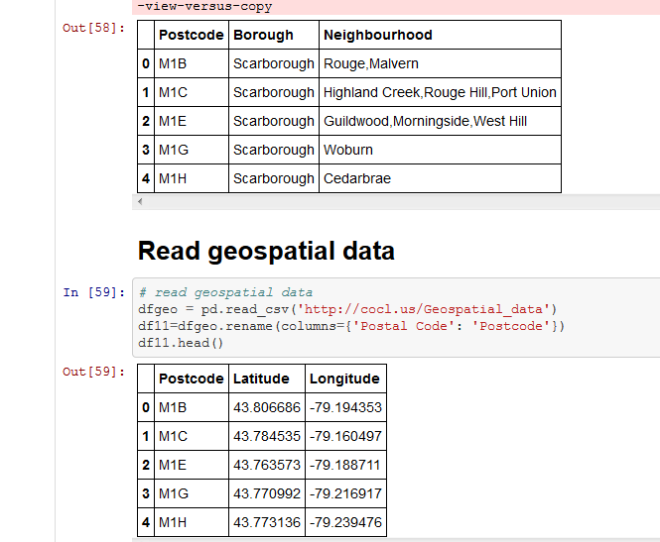

**2.3 Data Feature Selection**

Let us first consider Luncheon catering - Food Truck Business We will be making use of Downtown Toronto Postal Codes data along with Foursquare API to get list of Business places in Downtown Toronto.

First we will use the List of Postal Codes of Canada for Downtown Toronto by web scraping from a Wikipedia website next using the 'Offices' or 'Business' keywords in Foursquare API we can search for all Business places in Downtown Toronto within a radius of 500.

The list of Offices that we receive can further be refined based on the user ratings of the venue. Or check-ins to the Business venue. This is an indicator of decent Customer footfall. Based on this data we can provide Clusters within the neighborhood where Food Trucks will do better business.

Furthermore, rankings of the Business based on ratings can also help in deciding which location is the best.

Like the above described scenarios we will also try to showcase data for Catering to Educational/College crowds.

For this we will search Foursquare using College or Education keywords and build a similar Supervised learning model as above.

1. **Exploratory Data Analysis**

We have to explore the Foursquare API dataset to search for Business places within Downtown Toronto. First, we built a dataset from the search output provided by Foursquare and then we plotted the same on a map to explore the neighborhood and surrounding areas.

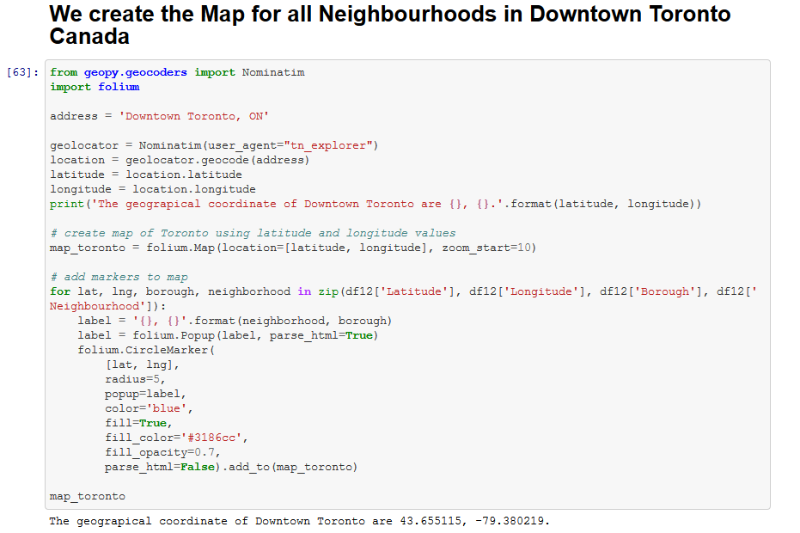

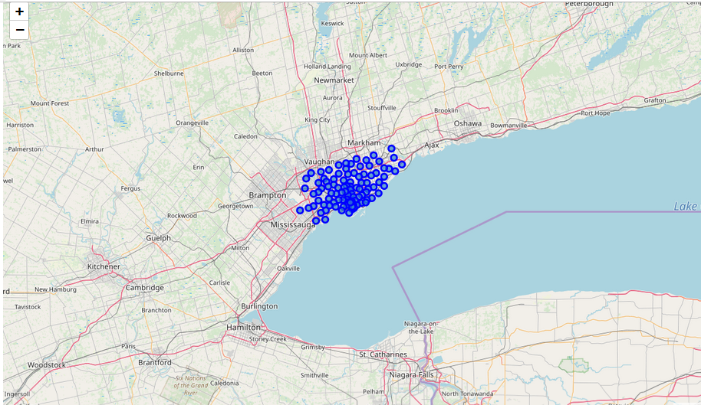

**4. Modeling with K Means Cluster**

Once we have a list of all the businesses with Latitude and Longitude, we can apply K Means Cluster to cluster the Business neighborhoods within Downtown Toronto into groups.

The groups can further help us refine the exact geographical locations where the Food Truck can be parked to get maximum benefit of footfalls. The below output is after the Clustering is done –

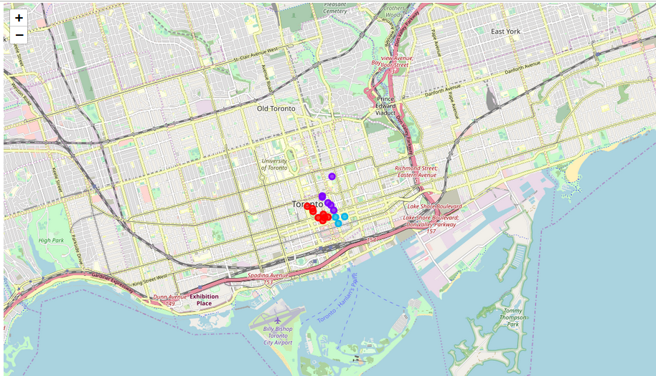

**5. Conclusions**

- Any food business before commencement will require a proper study of location, menu, target crowd and market demands.

- This study will help in the ideal placement of a Food Truck and gauge the risks faced by a business with regards to location & geo limitations.

- Finally, the above analysis can be applied to any Mobile Food van that requires Location Analytics.